**Cloud Computing 101**

The cloud is a part of everyday life. For companies everywhere, it’s become an ideal solution for their technology needs. With its ability to scale, on-demand solutions, and flexible pricing, companies can focus on bringing their ideas to life rather than buying and managing servers.

What does this mean for your career? If you’re interested in a job in technology, knowledge of cloud computing is essential. Start with Cloud Computing 101 to build a foundation and grow your expertise.

* **Skills to Succeed**

Learn about the AWS solutions that companies large and small and across the globe use to build their businesses, including compute, storage, analytics, databases, networking, and developer tools.

* **25 Hours of Learning**

With a mix videos, papers, labs, and quizzes to assess your learning, explore the world of cloud computing in the way you prefer, and at your own pace.

* **Prepare for the Future**

Employees in technology often have degrees in fields like Computer Science, Information Technology, or Engineering, and/or demonstrated experience in the skills included in the Cloud Career Pathways.

**AWS Cloud Computing Fundamentals**

Cloud computing is the on-demand delivery of compute power,database storage, applications, and other IT resources through a cloud services platform via the Internet with pay-as-you-go pricing.

Whether you are running applications that share photos to millions of mobile users or you’re supporting the critical operations of your business, a cloud services platform provides rapid access to flexible and low-cost IT resources. With cloud computing, you don’t need to make large upfront investments in hardware and spend a lot of time on the heavy lifting of managing that hardware. Instead, you can provision exactly the right type and size of computing resources you need to power your newest bright idea or operate your IT department.

You can access as many resources as you need, almost instantly, and only pay for what you use.

Cloud computing provides a simple way to access servers, storage, databases and a broad set of application services over the Internet. A cloud services platform such as Amazon Web Services owns and maintains the network-connected hardware required for these application services, while you provision and use what you need via a web application.

**History**

In 2006, Amazon Web Services (AWS) began offering IT infrastructure services to businesses as web services—now commonly known as cloud computing. One of the key benefits of cloud computing is the opportunity to replace upfront capital infrastructure expenses with low variable costs that scale with your business. With the cloud, businesses no longer need to plan for and procure servers and other IT infrastructure weeks or months in advance. Instead, they can instantly spin up hundreds or thousands of servers in minutes and deliver results faster.

Today, AWS provides a highly reliable, scalable, low-cost infrastructure platform in the cloud that powers hundreds of thousands of businesses in 190 countries around the world.

**Cloud Benefits**

**- Trade capital expense for variable expense** – Instead of having to invest heavily in data centers and servers before you know how you’re going to use them, you can pay only when you consume computing resources, and pay only for how much you consume.

**- Benefit from massive economies of scale** – By using cloud computing, you can achieve a lower variable cost than you can get on your own. Because usage from hundreds of thousands of customers is aggregated in the cloud, providers such as AWS can achieve higher economies of scale, which translates into lower pay as-you-go prices.

**- Stop guessing about capacity** – Eliminate guessing on your infrastructure capacity needs. When you make a capacity decision prior to deploying an application, you often end up either sitting on expensive idle resources or dealing with limited capacity. With cloud computing, these problems go away. You can access as much or as little capacity as you need, and scale up and down as required with only a few minutes’ notice.

**- Increase speed and agility** – In a cloud computing environment, new IT resources are only a click away, which means that you reduce the time to make those resources available to your developers from weeks to just minutes. This results in a dramatic increase in agility for the organization, since the cost and time it takes to experiment and develop is significantly lower.

**- Stop spending money running and maintaining data centers** – Focus on projects that ifferentiate your business, not the infrastructure. Cloud computing lets you focus on your own customers, rather than on the heavy lifting of racking, stacking, and powering servers.

Go global in minutes – Easily deploy your application in multiple regions around the world with just a few clicks. This means you can provide lower latency and a better experience for your customers at minimal cost.

**Total Cost of Ownerhip**

AWS helps you reduce Total Cost of Ownership (TCO) by reducing the need to invest in large capital expenditures and providing a pay-as-you-go model that empowers you to invest in the capacity you need and use it only when the business requires it. Our TCO calculators allow you to estimate the cost savings when using AWS and provide a detailed set of reports that can be used in executive presentations. The calculators also give you the option to modify assumptions that best meet your business needs.

The TCO Calculator provides directional guidance on possible realized savings when deploying AWS. This tool is built on an underlying calculation model, that generates a fair assessment of value that a customer may achieve given the data provided by the user. This tool is for approximation purposes only

**Typer of Cloud Computing**

Cloud computing is providing developers and IT departments with the ability to focus on what matters most and avoid undifferentiated work like procurement, maintenance, and capacity planning. As cloud computing has grown in popularity, several different models and deployment strategies have emerged to help meet specific needs of different users. Each type of cloud service, and deployment method, provides you with different levels of control, flexibility, and management. Understanding the differences between Infrastructure as a Service, Platform as a Service, and Software as a Service, as well as what deployment strategies you can use, can help you decide what set of services is right for your needs.

* **Infrastructure as a Service (IaaS):**

Infrastructure as a Service, sometimes abbreviated as IaaS, contains the basic building blocks for cloud IT and typically provide access to networking features, computers (virtual or on dedicated hardware), and data storage space. Infrastructure as a Service provides you with the highest level of flexibility and management control over your IT resources and is most similar to existing IT resources that many IT departments and developers are familiar with today.

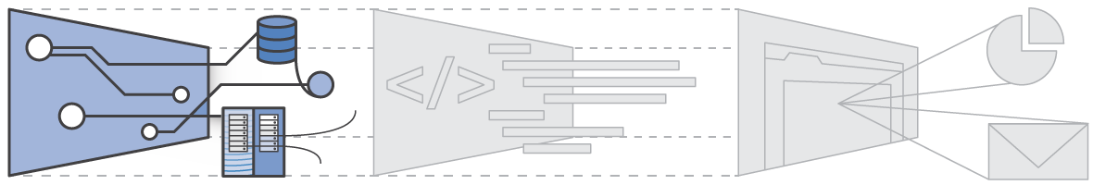

* **Platform as a Service (PaaS):**

Platforms as a service remove the need for organizations to manage the underlying infrastructure (usually hardware and operating systems) and allow you to focus on the deployment and management of your applications. This helps you be more efficient as you don’t need to worry about resource procurement, capacity planning, software maintenance, patching, or any of the other undifferentiated heavy lifting involved in running your application.

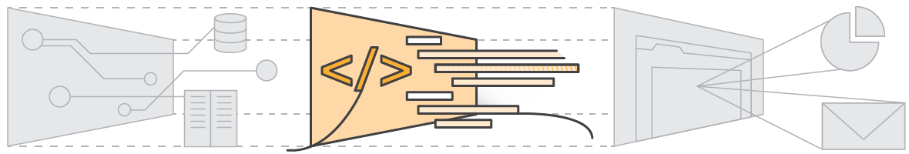

* **Software as a Service (SaaS):**

Software as a Service provides you with a completed product that is run and managed by the service provider. In most cases, people referring to Software as a Service are referring to end-user applications. With a SaaS offering you do not have to think about how the service is maintained or how the underlying infrastructure is managed; you only need to think about how you will use that particular piece software. A common example of a SaaS application is

web-based email where you can send and receive email without having to manage feature additions to the email product or maintaining the servers and operating systems that the email program is running on.

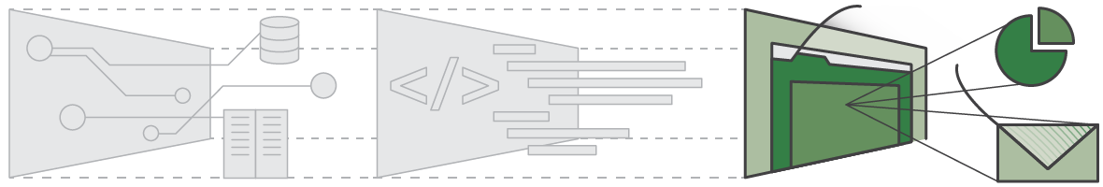

**Deployment Models**

* **Cloud**

A cloud-based application is fully deployed in the cloud and all parts of the application run in the cloud. Applications in the cloud have either been created in the cloud or have been migrated from an existing infrastructure to take advantage of the benefits of cloud computing. Cloud-based applications can be built on low-level infrastructure pieces or can use higher level services that provide abstraction from the management, architecting, and scaling requirements of core infrastructure.

* **Hybrid**

A hybrid deployment is a way to connect infrastructure and applications between cloud-based resources and existing resources that are not located in the cloud. The most common method of hybrid deployment is between the cloud and existing on-premises infrastructure to extend, and grow, an organization's infrastructure into the cloud while connecting cloud resources to the internal system. For more information on how AWS can help you with your hybrid

deployment, please visit our hybrid page.

* **On-premises**

The deployment of resources on-premises, using virtualization and resource management tools, is sometimes called the “private cloud.” On-premises deployment doesn’t provide many of the benefits of cloud computing but is sometimes sought for its ability to provide dedicated resources. In most cases this deployment model is the same as legacy IT infrastructure while using application management and virtualization technologies to try and increase resource utilization.

**Global Infrastructure**

AWS serves over a million active customers in more than 190 countries. We are steadily expanding global infrastructure to help our customers achieve lower latency and higher throughput, and to ensure that their data resides only in the AWS Region they specify. As our customers grow their businesses, AWS will continue to provide infrastructure that meets their global requirements.

The AWS Cloud infrastructure is built around AWS Regions and Availability Zones. An AWS Region is a physical location in the world where we have multiple Availability Zones. Availability Zones consist of one or more discrete data centers, each with redundant power, networking, and connectivity, housed in separate facilities. These Availability Zones offer you the ability to operate production applications and databases that are more highly available, fault tolerant, and scalable than would be possible from a single data center. The AWS Cloud operates 42 Availability Zones within 16 geographic Regions around the world, with five more Availability Zones and two more Regions coming online in 2017.

Each Amazon Region is designed to be completely isolated from the other Amazon Regions. This achieves the greatest possible fault tolerance and stability. Each Availability Zone is isolated, but the Availability Zones in a Region are connected through low-latency links.

AWS provides you with the flexibility to place instances and store data within multiple geographic regions as well as across multiple Availability Zones within each AWS Region. Each Availability Zone is designed as an independent failure zone. This means that Availability Zones are physically separated within a typical metropolitan region and are located in lower risk flood plains (specific flood zone categorization varies by AWS Region). In addition to discrete uninterruptable power supply (UPS) and onsite backup generation facilities, they are each fed via different grids from independent utilities to further reduce single points of failure. Availability Zones are all redundantly connected to multiple tier-1 transit providers.

**Security And Compliance**

Cloud security at AWS is the highest priority. As an AWS customer, you will benefit from a data center and network architecture built to meet the requirements of the most security-sensitive organizations.Security in the cloud is much like security in your on-premises data centers—only without the costs of maintaining facilities and hardware.

In the cloud, you don’t have to manage physical servers or storage devices. Instead, you use software-based security tools to monitor and protect the flow of information into and of out of your cloud resources.

An advantage of the AWS Cloud is that it allows you to scale and innovate, while maintaining a secure environment and paying only for the services you use. This means that you can have the security you need at a lower cost than in an on-premises environment.

As an AWS customer you inherit all the best practices of AWS policies, architecture, and operational processes built to satisfy the requirements of our most security-sensitive customers. Get the flexibility and agility you need in security controls.

The AWS Cloud enables a shared responsibility model. While AWS manages security of the cloud, you are responsible for security in the cloud. This means that you retain control of the security you choose to implement to protect your own content, platform, applications, systems, and networks no differently than you would in an on-site data center.

AWS provides you with guidance and expertise through online resources, personnel, and partners. AWS provides you with advisories for current issues, plus you have the opportunity to work with AWS when you encounter security issues.

You get access to hundreds of tools and features to help you to meet your security objectives. AWS provides security-specific tools and features across network security, configuration management, access control, and data encryption.

Finally, AWS environments are continuously audited, with certifications from accreditation bodies across geographies and verticals. In the AWS environment, you can take advantage of automated tools for asset inventory and privileged access reporting.

**Benefits of AWS Security**

* Keep Your Data Safe: The AWS infrastructure puts strong safeguards in place to help protect your privacy. All data is stored in highly secure AWS data centers.
* Meet Compliance Requirements: AWS manages dozens of compliance programs in its infrastructure. This means that segments of your compliance have already been completed.
* Save Money: Cut costs by using AWS data centers. Maintain the highest standard of security without having to manage your own facility
* Scale Quickly: Security scales with your AWS Cloud usage. No matter the size of your business, the AWS infrastructure is designed to keep your data safe.

AWS Cloud Compliance enables you to understand the robust controls in place at AWS to maintain security and data protection in the cloud. As systems are built on top of AWS Cloud infrastructure, compliance responsibilities will be shared. By tying together governance-focused, audit-friendly service features with applicable compliance or audit standards, AWS Compliance enablers build on traditional programs. This helps customers to establish and operate in an AWS security control environment.

The IT infrastructure that AWS provides to its customers is designed and managed in alignment with best security practices and a variety of IT security standards. The following is a partial list of assurance programs with which AWS complies:

- SOC 1/ISAE 3402, SOC 2, SOC 3

- FISMA, DIACAP, and FedRAMP

- PCI DSS Level 1

- ISO 9001, ISO 27001, ISO 27018

AWS provides customers a wide range of information on its IT control environment in whitepapers, reports, certifications, accreditations, and other third-party attestations. More information is available in the Risk and Compliance whitepaper and the AWS Security Center.

**Careers**

Through the AWS Educate program, we are driving exposure to a handful of important and critical...

* Cloud Support Associate
* Cloud Support Engineer
* Data Scientist
* Data Integration Specialist
* Software Engineer
* Application Developer
* DevOps Engineer
* Web Development Engineer
* Cybersecurity Specialist
* Machine Learning Specialist

**References**

https://docs.aws.amazon.com/aws-technical-content/latest/aws-overview/what-is-cloud-computing.html

https://commons.wikimedia.org/wiki/File:Cloud_computing_layers.png

https://docs.aws.amazon.com/aws-technical-content/latest/aws-overview/introduction.html

https://docs.aws.amazon.com/aws-technical-content/latest/aws-overview/six-advantages-of-cloud-computing.html

https://docs.aws.amazon.com/aws-technical-content/latest/aws-overview/types-of-cloud-computing.html

https://docs.aws.amazon.com/aws-technical-content/latest/aws-overview/global-infrastructure.html

https://docs.aws.amazon.com/aws-technical-content/latest/aws-overview/security-and-compliance.html

https://aws.amazon.com/tco-calculator/